**Title???  
- Climate response of coniferous trees in northern latitudes: longitudinal gradient from west to east**

**- Response of forest ecosystems to climate change beyond the Arctic Circle**

**- Influence of longitudinal climate gradient on larch and pine growth in the Arctic region**

**- Climate response of coniferous trees in the Arctic region: west-east gradient**

**- Regional differences in the climate response of coniferous trees in Arctic climate conditions**

Kristina V. Akulinina, Alexander V. Kirdyanov, Vladimir V. Kukarskih, Alexey I. Kolmogorov, Victoria V. Agapova, Alberto Arzac

**Abstract**

An increase in temperature in high latitudes will lead to changes in the water balance and thermal regime of permafrost soils, which will affect the structure and functioning of plant communities in northern экосистем. A method for studying the response of plant communities to environmental and climate changes is dendroclimatic analysis of the radial growth of trees. The article presents the results of such an analysis for the trees *Pinus sylvestris, Larix sibirica, Larix gmelinii and Larix cajanderi*, growing in a zone of continuous permafrost in six areas within the Arctic Circle.

A correlation analysis was carried out between tree ring width indices and climate indicators for the period from 1966 to 2021. The results showed that the main factor limiting the radial growth of trees in all study areas is air temperature, mainly in June and July. Sliding correlations showed that in recent decades there has been an increase in the influence of temperature anomalies on tree growth, especially under conditions of increasing average daily temperature. This indicates potential changes in the structure of plant communities and their adaptation to new climatic conditions. It was also noted that an increase in temperature in the summer months leads to a more pronounced positive dynamics of radial growth, which may be associated with improved photosynthetic processes and increased water availability under conditions of permafrost thawing. In conclusion, the results emphasize the importance of further research aimed at assessing long-term changes in northern ecosystems in response to global warming.

**Keywors:** Arctic, climate change, tree growth, tundra,treeline, permafrost, radial growth

1. **Introduction**

In the last decade, an unusual phenomenon has been observed in the Arctic region: unprecedented warming in the forest-tundra ecotone. This climate change has a significant impact on the dynamics of экосистем in this region. However, the effects of warming are not limited to changes in plant communities. They also affect deep soil processes, influencing the timing of the formation of the active soil layer in areas of continuous permafrost.

In addition to negative effects, rising temperatures can also create favorable conditions for tree growth. Higher temperatures and earlier access to water due to thawing permafrost can contribute to the flourishing of vegetation in the region. Research (Vaganov E.A., Hughes M.K., Kirdyanov A.V., Schweingruber F.H., Silkin P.P., 1999) confirms that all these factors are already affecting the condition of forests and their components. Such changes can have consequences not only for biodiversity, but also for ecosystems in general.

The width of tree rings is directly related to growth conditions, which depend on temperature, precipitation, and other environmental factors. The aim of the work is to assess the climate response of tree radial growth to changes in temperature, precipitation, active soil depth, snow depth, and wood species.

Studying these changes and their possible consequences is becoming increasingly important in the context of global climate change and anthropogenic activities. In addition, changes in forest-tundra ecosystems can serve as indicators of broader climate trends, making their study key to assessing future change scenarios in Arctic regions.

**2.** **Materials and methods**

**2.1 Study area and sampling**

The research was carried out at six localities in a longitudinal transect above the Arctic Circle, from northeastern Finland to northeastern Russia (27°E to 166°E; Fig. 1A). Four main conifer species in the forest-tundra ecotone were sampled (i.e., *Pinus sylvestris*, *Larix sibirica*, *Larix* *gmelinii* and *Larix cajanderi*). Thus, in the westernmost sites, Finland (hereafter FIN) and Apatity in the Kola Peninsula (hereafter APA) - *P. sylvestris*. In the central sites, the Polar Urals (hereafter PUR) - *L. sibirica* and Khatanga (hereafter KHA) - *L.gmelinii*. In the easternmost sites Chokurdakh (hereafter CHO) and Bilibino (hereafter BIL) *L. cajanderi*. The sites are characterized by harsh climatic conditions that significantly affect the growth and development of tree species. Temperature fluctuations, short growing seasons and low precipitation levels create specific conditions. Thus, over the 1966-2021 period, mean annual air temperature ranges from 0,3 °C in APA to -13,1°C in CHO (Fig. 1B), and the annual precipitation totals from 558 mm in the APA to 210 mm in BIL (Fig. 1B). Climate data from the nearest weather station to the sampling sites were obtained from climexp.knmi.nl (Finnish site) [] and www.meteo.ru (Russian sites) [].

The average annual temperature trend for each site shows a general increasing trend (Fig. 1C), as do the temperatures of the combined months (June–September) (Fig. 1D). Average number of days per year with temperatures equal to or above 5 °C for the study period 1966–2021 was 133 days and 70 days for the APA and CHO sections, respectively (Table 1). In addition, there is an increase in the number of days with temperatures equal to or above 5 °C at a variable rate from 44 to 52 days per decade at P < 0.01 for the more western and central sites, and 29 days per decade for Chokurdakh and 11 days for Bilibino (P < 0.01) (Supplement, Fig. 1A).

At each site, a minimum of 20 trees were sampled at breast height (1.3 m) with a 5-mm increment borer powered by an electric drill. Tree height and diameter at breast height (dbh) were recorded for the sampled trees (Table 1).

Since the study areas are located in the Arctic Circle, the soil conditions of each area are affected by permafrost. The depth of seasonal soil thawing (active layer) is greatest in the western regions (FIN, APA), where permafrost is either absent or has an insular character. It can reach 1–2 m. The soils in these areas are podzolic and peat-podzolic, with a fairly high organic content, which contributes to better moisture capacity. In the Polar Urals (PUR) and in Khatanga (KHA), there is a discontinuous type of permafrost, which is transitional to continuous permafrost, the thickness of the seasonal thawed layer is reduced to 50–100 cm, and the soils are mountain-tundra or tundra-gley. In Chokurdakh (CHO) and Bilibino (BIL), continuous permafrost with a freezing depth of tens of meters is widespread. Here, the active layer is on average 30–60 cm, and the soils (cryozems, tundra-gley) are poor in organic matter and exhibit low microbiological activity. The water regime is largely determined by the speed of snow melting in spring and summer temperatures. In such conditions, soil thawing begins later, but occurs intensively in a short period, which increases the dependence of trees on early summer temperatures.

A 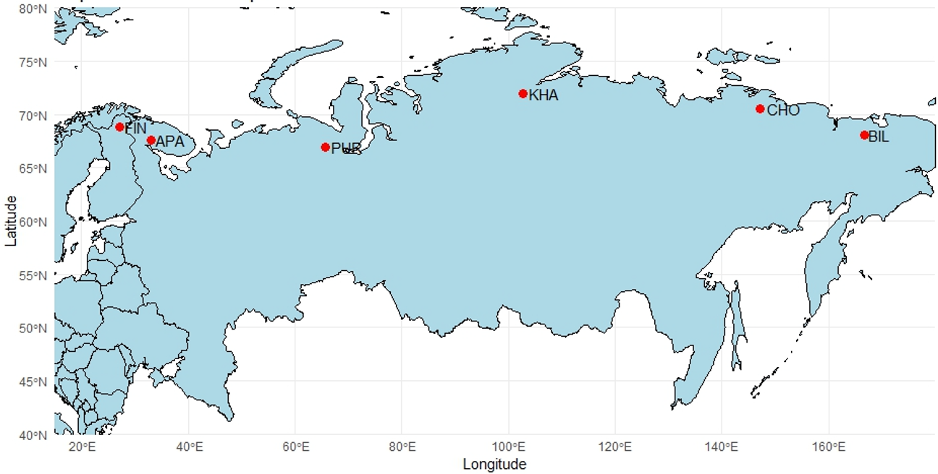

B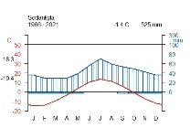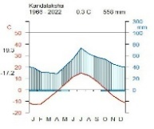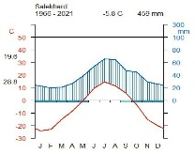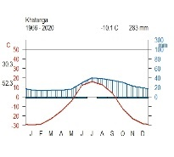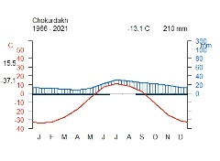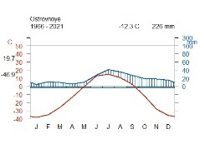

C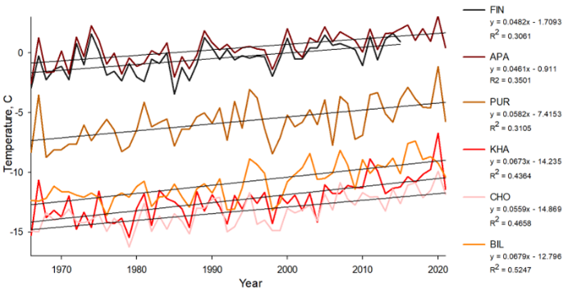 D 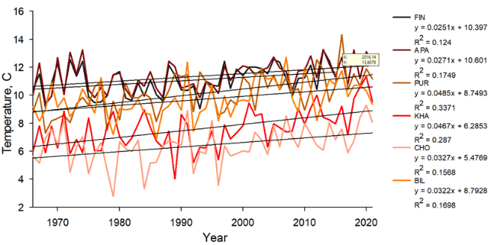

**Figure 1.** Location and climate of the study area: (A) white dots show the location of sampling sites (FIN, Finland, APA, Apatity; PUR, Polar Ural; KHA, Khatanga; CHO, Chokurdakh; BIL, Bilibino). (B) Climate diagram for Sodankyla weather stations, Kandalaksha, Salekhard, Khatanga, Chokurdakh, Ostrovnoye for 1966 – 2021 period. (C) Average annual temperature trends for the periods 1966–2021 in the study areas. (D) Trends in average monthly temperature June-September for the period 1966–2021 in the study areas.

**Table 1** - Characteristics of areas

|  |  |  |  |  |  |  |
| --- | --- | --- | --- | --- | --- | --- |
|  | FIN | APA | PUR | KHA | CHO | BIL |
| Coordinates | 68°77′ N  27°15' E | 67°36' N  33°2' E | 66°54' N  65°45' E | 71°57' N  102°40'E | 70°30' N  147°10' E | 68°02′ N  166°40' E |
| Elevation (masl) | 179 | 127 | 125 | 35 | 7 | 468Начало формы |
| Near weatherstation | Sodankyla  (52 km) | Kandalaksha  (62 km) | Salekhard  (58 km) | Khatanga  (7 km) | Chokurdakh  (2 km) | Ostrovnoye  (48 km) |
| T mean | -0.48 | 0.40 | -5.76 | -12.32 | -13.28 | -10.86 |
| T June-July | 13.09 | 13.05 | 11.90 | 9.43 | 8.31 | 13.05 |
| T June-September | 11.04 | 11.37 | 10.13 | 7.62 | 6.41 | 9.71 |
| P total | 526.56 | 547.48 | 457.21 | 283.10 | 210.40 | 237.10 |
| P June-July | 124.86 | 124.42 | 118.98 | 68.60 | 52.30 | 69.10 |
| P June-September | 235.50 | 242.80 | 229.53 | 141.14 | 104.36 | 131.05 |
| Days  ≥ 5 °C | 121+12,2 | 133+12,2 | 105+13,6 | 82+13,1 | 70+12,7 | 93+11,4 |

The vegetation period is short in all areas (approximately 70 to 130 days). In Finland (FIN) and Apatity (APA), the period with temperatures above +5 °C lasts longer, while in Chokurdakh (CHO) and Bilibino (BIL) it may not exceed 70–90 days. Scots pine has permanent needles, allowing it to maintain photosynthesis during periods of sharp “warming” even at the beginning of spring. Larches shed their needles annually, which makes their growth more dependent on the conditions of the current summer. With rapid warming in June, larches get a “starting” advantage if they manage to form needles and begin active growth. However, in cold years, late thawing of the soil can significantly slow down the development of larch.

**2.2 RW measurements and chronologies construction**

The collected cores were subjected to resin extraction using a Soxhlet apparatus with 96% ethanol for 72 hours. After this, wood cores were fixed on wooden supports and polished with a grinding machine with a grit up to 1000. An Epson Perfection V800 flatbed scanner (Epson, Japan) was used to scan the polished cores. Tree-ring width (RW) was measured using CooRecoder version 9.3 (Cybis Elektronik & Data AB in Sweden). The wood cores were visually cross-dated and its accuracy was statistically checked with COFECHA (Grissino-Mayer 2001). In the ARSTAN program (Cook E.R., Holmes R.1996), standardization (indexing) of the original time series was performed using a negative exponential or linear function to compensate for age-related changes in ring width. Next, a procedure was carried out to remove the autocorrelation component in order to reduce the influence of non-climatic factors and preserve the high-frequency climate response (Cook E.R., Peters K.,1981). To assess the quality of the obtained chronologies, the following statistical parameters were calculated: sensitivity coefficient (msx), inter-series correlation coefficient (Rbar) and expressed population signal (EPS) (Table 2) (Wigley T.M.L., Briffa K.R., Jones P.D. 1984).

Table 2 - Сhronology characteristics for the period 1966–2021

|  |  |  |  |  |  |  |
| --- | --- | --- | --- | --- | --- | --- |
|  | **FIN** | **APA** | **PUR** | **KHA** | **CHO** | **BIL** |
| msx | 0.25 | 0.25 | 0.40 | 0.55 | 0.44 | 0.44 |
| EPS | 0.65 | 0.89 | 0.96 | 0.96 | 0.97 | 0.96 |
| Rbar | 0.48 | 0.40 | 0.63 | 0.68 | 0.64 | 0.69 |

**2.3 Statistical analysis of climate relationships**

To assess the relationship between tree growth and climate parameters, Pearson correlation analysis was used between tree-ring indices and average monthly temperature and precipitation for the period 1966–2021, from September of the previous year to September of to current.. Additionally, daily moving correlations were calculated to evaluate peaks in the climate signal over time. Monthly moving correlations The analysis of temporal and spatial stability was carried out by comparing correlations in different time windows and different areas. Cluster analysis allowed us to identify groups of sites based on similar variations in tree-ring width.

Monthly correlqtions

Daily moving correlatins

Yearly moving

Field correltions

**3. Results**

**3.1. Chronologies description**

**3.2 Climate-growth analysis**

To assess the relationship between tree radial growth and climatic conditions, a pairwise correlation analysis was performed using Pearson correlation coefficients. The analysis was performed between standard chronologies and average monthly climatic data, including total precipitation and average air temperature. The result between residual chronologies is in Supplement 2).

Tree-ring width showed a positive correlation with summer temperatures (June and July), but the timing and intensity of the climate signal varied between sites. Trees at sites PUR, KHA and BIL showed an earlier response to June temperature (r = 0.54; r = 0.43; r = 0.41, respectively, at P < 0.01), site CH r = 0.24 at P < 0.05, except for the westernmost sites (FIN and APA), where a significant relationship was found only for July temperature (r = 0.35 and 0.41, respectively, at P < 0.01) (Fig. 2A). Temperatures of the previous months, as well as March, had a significant negative effect on the radial growth of trees in the Chokurdakh area (Fig. 2A).

Correlation analysis between residual chronologies and monthly precipitation showed that precipitation affected radial growth only at the local level, without a clear pattern for all the study areas. Summer precipitation did not demonstrate a statistically significant effect on radial growth in the considered areas. The most noticeable positive effect of precipitation was found for the APA area in August (r = -0.39, p < 0.01) and in December of the previous year (r = -0.35, p < 0.01) (Fig. 2B). For the easternmost area (BIL), last year's October precipitation had a positive effect (r = -0.41, p < 0.01) and April precipitation had a negative effect (r = -0.37, p < 0.01) (Fig. 2B). In general, no long-term impact of precipitation on the radial growth of trees was detected in any of the study areas.

А 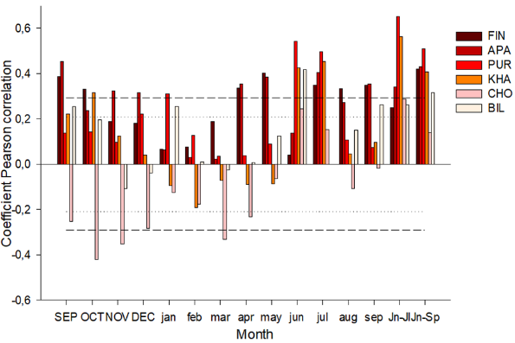B 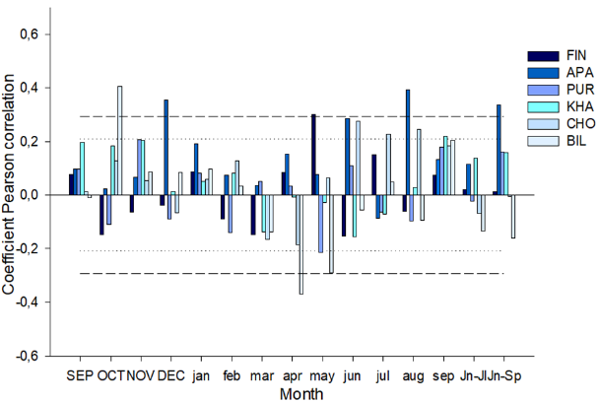

**Figure 2.** Coefficients of paired (A and B) correlations of tree-ring width with temperature and precipitation

Sliding correlations calculated on the basis of average daily data showed a positive influence of midsummer temperatures (June 23 – July 10) in all study areas (Fig. 3A). However, when moving from west to east along the northern profile, an increase in the maximum correlation coefficients is noted, as well as their shift to earlier dates. The seasonal dynamics of the influence of temperatures demonstrates a decrease in the significance of July temperatures and an increase in the influence of June temperatures on the variability of tree growth indices. In the western regions (FIN, APA), where Scots pine grows, the effect of July temperatures is weaker (DOY 191 and 190; r = 0.43 and 0.41; p < 0.01) compared to other locations where larch grows: the central sites (PUR, KHA), where the correlation coefficients reach a maximum (DOY 174 and 181; r = 0.65 and 0.67; p < 0.01), and the eastern sites of CHO and BIL (DOY 183 and 176; r = 0.56 and 0.54, respectively; p < 0.01). Analysis of the effect of precipitation did not reveal a significant long-term effect on the radial growth of trees at any of the study sites (Fig. 3A).

A 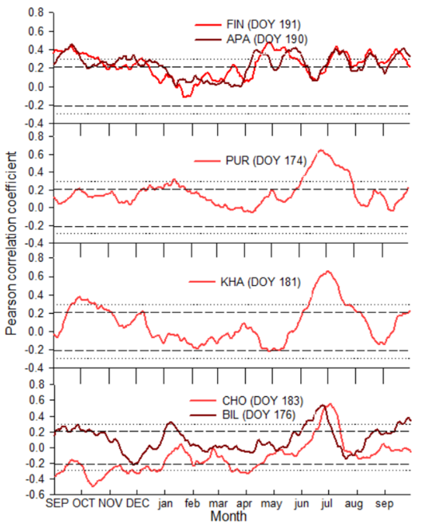 B 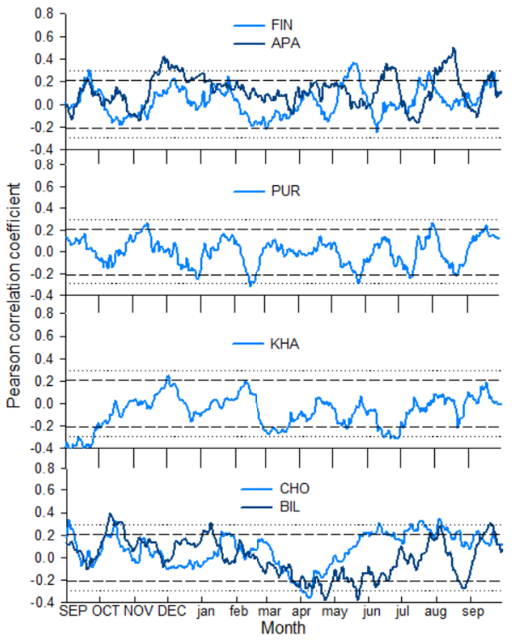

**Figure 3.** Sliding correlation coefficients (A and B) between standard tree-ring width indices and climate data (temperature and precipitation)

**3.2 Temporal stability of temperature signals**

Current correlations between standard chronologies show both positive and negative correlations with temperature for both individual months and aggregated temperatures of several months over the entire period. For the FIN and APA sites, there is no correlation with June temperatures over the entire period. Starting from 1976, the correlation shows the highest values, but also remains inconstant over time.

The central sites demonstrate stronger, and also constant over time, temperature responses for all considered months than in the other sites. Correlations for all months remain significant, but starting from the 1990s, the temperature signal gradually decreases.

For the CHO site, the temperature signal begins to decrease over time and around 1980 becomes insignificant for all considered months. On the contrary, for the Bilibino site, the correlations shifted over time to an increase in values ​​(around 1980), showing a higher response to all temperatures except July.

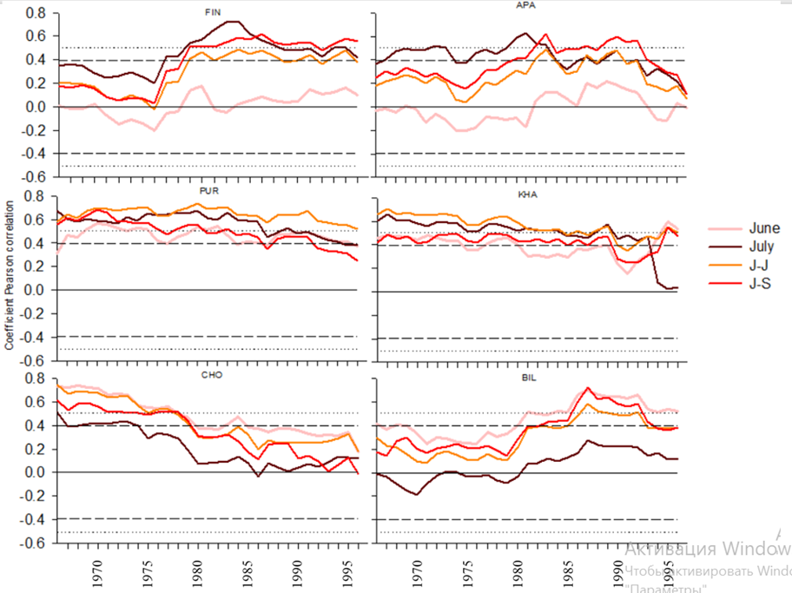

**Figure 4.** Sliding correlations (25-year window with 1-year step) of tree-ring widths with June, July, June-July, June-September temperatures for the total period 1966–2021

**3.3 Spatial stability of temperature signals**

Spatial correlation fields confirm the strong influence of June–July mean temperatures on PUR and KHA (r = 0.6 and 0.5 (P < 0.001), respectively). CHO show lower correlations for these months. Correlations of tree-ring width with June–September mean temperatures are high for FIN, APA, PUR, and KHA, reaching r = 0.3 for all sites except PUR (r = 0.4,) at P < 0.001 (Fig. 4A). Correlations with temperatures of the first two summer months are absent in June for FIN and APA and in July for BIL. June temperatures were moderately correlated with TRW for the CHO and BIL sites (r = 0.001, r = 0.001), respectively (Figure 4A), and July temperatures were moderately correlated with FIN and APA (r = 0.001, r = 0.001), respectively (Fig. 5).

|  |  |  |  |  |
| --- | --- | --- | --- | --- |
|  | JUN | JUL | JUN- JUL | JUN-SEP |
| FIN |  |  |  |  |
| APA |  |  |  |  |
| PUR |  |  |  |  |
| KHA |  |  |  |  |
| CHO |  |  |  |  |
| BIL |  |  |  |  |



**Figure 5.** Spatial field correlations between June, July, June–July and June–September mean temperatures (Berkeley 1°) and tree-ring widths for the period 1966–2001. Black dots indicate the locations of sampling sites.

**3.4 Tree-ring width analysis**

Correlation analysis between standard chronologies showed significant values ​​for the FIN and APA regions (r = 0.46), where *Pinus sylvestris* grows, and for the CHO and BIL regions (r = 0.36), where *Larix cajanderi* grows. No significant values ​​were found for other regions (PUR, KHA), where the main species are *Larix sibirica* and *Larix gmelinii*.

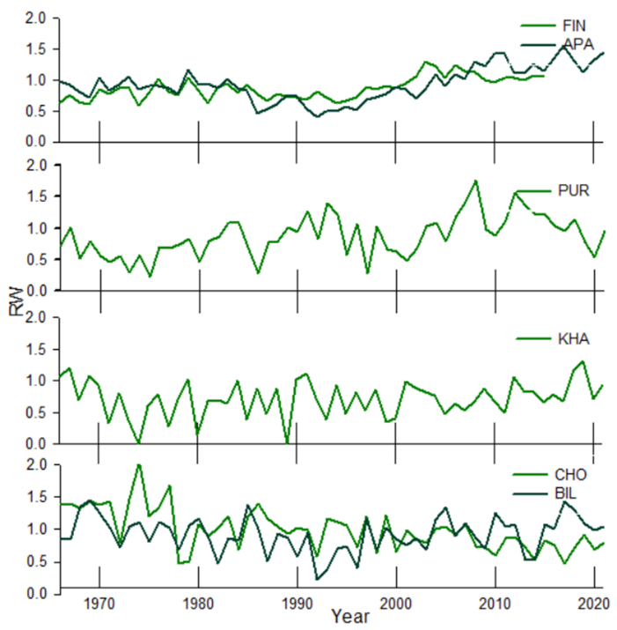

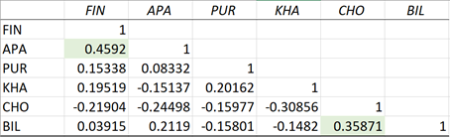

**Figure 6.** Sорар

Based on the cluster analysis of tree-ring width, conducted using the principal component analysis (PCA), three main groups of sites can be distinguished, reflecting the influence of climatic factors and the characteristics of dominant tree species on radial increment. The sites Apatity and Finland (*Pinus sylvestris*), Bilibino (*Larix cajanderi*) formed a single cluster, indicating the similarity of their tree-ring widths. This is due to the moderate climatic conditions characteristic of Apatity and Finland, and the adaptation of *Larix cajanderi* in Bilibino, despite the difference in dominant species. The second cluster united the Polar Urals (*Larix sibirica*) and Khatanga (*Larix gmelinii*), where larches demonstrate similar responses to severe climatic conditions, such as a short growing season and permafrost. The Chokurdakh (*Larix cajanderi*) site is allocated as a separate cluster, which reflects the uniqueness of growing conditions that affect the dynamics of tree growth due to abiotic factors.

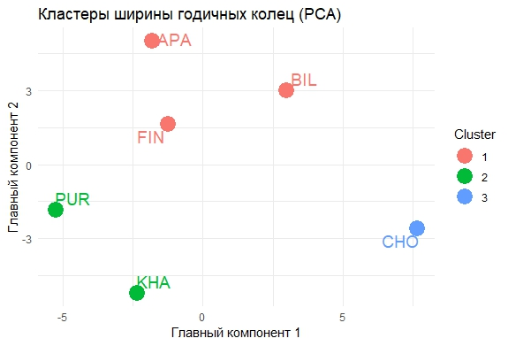

**Figure 7.** Cluster analysis of tree-ring widths of all sites' chronologies

snow depth - Remove, add to app or need to describe results?

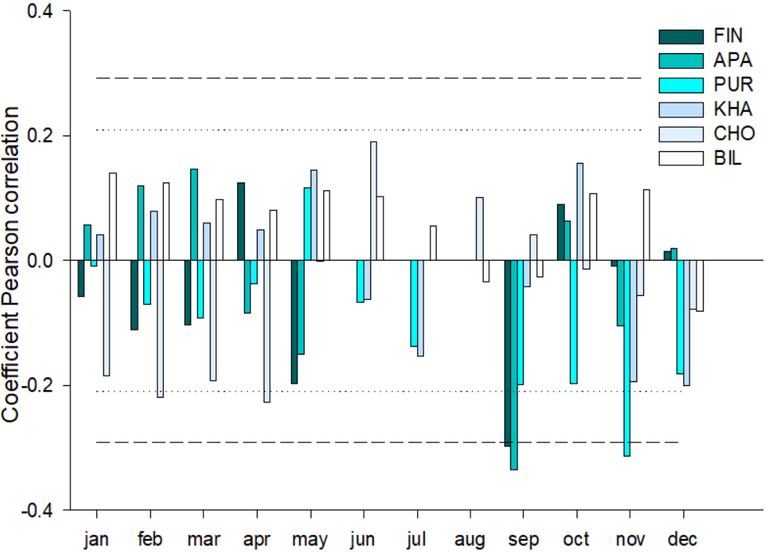

**Discussion**

The radial growth of trees in northern latitudes depends significantly on the temperature of the summer months (primarily June and July). This effect is expressed in regional features of the response of trees to climatic signals. The longitudinal gradient of the response to thermal conditions is manifested in the fact that in the western areas (FIN, APA), where permafrost is either absent or fragmentary (island-like), July temperatures have a more significant effect on tree growth. Here, the growing season begins later, and the peak of active growth of the annual ring occurs in mid-summer. Increased precipitation compared to more eastern areas and a greater thickness of the active soil layer also increase the availability of moisture and nutrients. In the central (PUR, KHA) and eastern (CHO, BIL) areas with a harsher climate and continuous permafrost, June is the most significant, which can be explained by the earlier onset of growth upon reaching the temperature threshold for photosynthesis and the formation of new needles. At the same time, the limited thickness of the active soil layer and the low nutrient content require the most efficient use of the short warm window in the summer season, so the trees are highly sensitive to June temperatures.

Despite the general tendency towards greater dependence on temperature, in some areas a weak but statistically significant effect of precipitation was revealed (in Apatity and Bilibino in certain months). These differences may be associated with local soil characteristics, as well as the timing and intensity of rainfall. In areas with continuous permafrost, heavy precipitation in the first half of summer may not have time to penetrate into the deep soil layers due to a weakly thawed layer, or vice versa - with intensive surface runoff, plants receive less water. ???

*Pinus sylvestris*, having permanent needles, is capable of starting photosynthetic activity earlier under relatively favorable conditions. However, in warmer western regions (FIN, APA), this advantage is partially offset by the climate, where the decisive factor is the peak of summer temperatures. Larches in conditions of continuous permafrost are forced to quickly "unfold" at the beginning of summer: form needles, carry out photosynthesis and lay down growth. Therefore, June temperatures are the most critical. Higher temperatures at the beginning of summer lead to a better initial growth phase, which is reflected in an increase in the width of annual rings.

**Conclusion**

The results of the study showed that the influence of climatic factors on the radial growth of trees along the longitudinal gradient in northern latitudes is diverse and depends on the regional characteristics of the territory.

The main climatic factor determining the radial growth of trees in the study areas is the temperature of the summer months. Precipitation did not have a significant impact. Pine and larch demonstrate different adaptation strategies to harsh conditions.

Supplements  
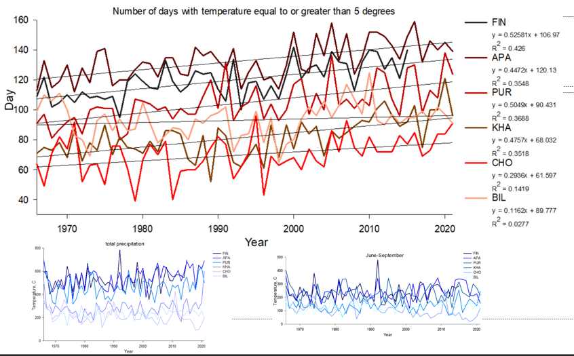

|  |  |  |  |  |  |  |
| --- | --- | --- | --- | --- | --- | --- |
|  | **FIN** | **APA** | **PUR** | **KHA** | **CHO** | **BIL** |
| Coordinates | 68°77′ N  27°15' E | 67°36' N  33°2' E | 66°54' N  65°45' E | 71°57' N  102°40' E | 70°30' N  147°10' E | 68°02′ N  166°40' E |
| Elevation (masl) | 179 | 127 | 125 | 35 | 7 | 468Начало формы |
| Near weatherstation | Sodankyla  (52 km) | Kandalaksha  (62 km) | Salekhard  (58 km) | Khatanga  (7 km) | Chokurdakh  (2 km) | Ostrovnoye  (48 km) |
| Number of trees | 35 | 18 | 26 | 18 | 20 | 20 |
| Average age of trees (years) | 162 ±59,4 | 263 ±73,6 | 133±35,9 | 300±36,7 | 331,35±118 | 163±22 |
| Mean dbh (cm) |  | 36.6 | 15.3 | 22.3 | 13.7 | 16.9 |
| Mean tree height (m) |  | 14.5 | 9 | 11.7 | 5.4 | 9.12 |
| Average tree ring width (mm) | 0,98+0,12 | 0,98+0,14 | 0,95+0,3 | 0,95+0,29 | 0,98+0,29 | 0,98+0,11 |
| Average number of days per year with temperature  ≥ 5 °C | 121+12,2 | 133+12,2 | 105+13,6 | 82+13,1 | 70+12,7 | 93+11,4 |
| Active soil layer deep (cm) | ? | ? | ? |  | 14 | ? |
| msx | 0.25 | 0.25 | 0.40 | 0.55 | 0.44 | 0.44 |
| EPS | 0.65 | 0.89 | 0.96 | 0.96 | 0.97 | 0.96 |
| Rbar | 0.48 | 0.40 | 0.63 | 0.68 | 0.64 | 0.69 |